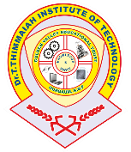
Dr.T. THIMMAIAH INSTITUTE OF TECHNOLOGY
(Estd. 1986) Oorgaum, Kolar Gold Fields, Karnataka – 563120
(Affiliated to VTU, Belgaum, Approved by AICTE - New Delhi)

2.2.1 The institution assesses the learning levels of the students and organizes special program’s for advanced learners and slow learners.

List of documents for slow learners activities

Sl. No. | Name of Documents | Link
1 | List of slow learners and advanced learners
2 | Remedial class attendance
3 | Tutorial classes time table
4 | Mentoring
5 | Module wise Question bank
6 | University question papers

